**CS-322 Software Construction**

**Data Dictionary**



**Project Management System**

**PRESENTED BY**

Name 1: Muhammad Rayyan (LEADER) (04072312024)

**SUPERVISED BY**

Dr. Onaiza Maqbool

Department of Computer Science

Quaid-e-Azam University, Islamabad

|  |  |
| --- | --- |
| Member Name | Use-case Text and System Sequence  Diagram |
| Muhammad Rayyan | UC 1,2 & SSD 1,2 |

**Use-Case Text**

**UC 1: Offer projects and assign supervisors**

* **Primary Actor:**

Administration

* **Precondition:**

The system must be operational, and the admin must be logged in.

* **Main Success Scenario:**

1. The administrator will enter the project details which include project title, project description etc.
2. The administrator will assign supervisors to the projects.
3. The system will save and publish the projects.

* **Alternate Scenario:**

1.2 If project details are incomplete, then the prompts for missing information.

1.3 If the supervisor is unavailable, the system prompts for another selection.

* **Postcondition:**

Projects are available for students to register, and supervisors are assigned.

**UC 2: Project Registration**

* **Primary Actor:**

Student

* **Precondition:**

The students must have a valid user account.

* **Main Success Scenario:**

1. Students browse the available projects.
2. Student selects a project and submits a request for registration.
3. The system confirms the registration.
4. Student receives confirmation of registration.

* **Alternate Scenario**

2.4 If the student changes their mind, they can cancel the registration.

* **Postcondition:**

The project is registered under the student along with the supervisor.

**System Sequence Diagram**

**UC 1: Offer projects and assign supervisors**

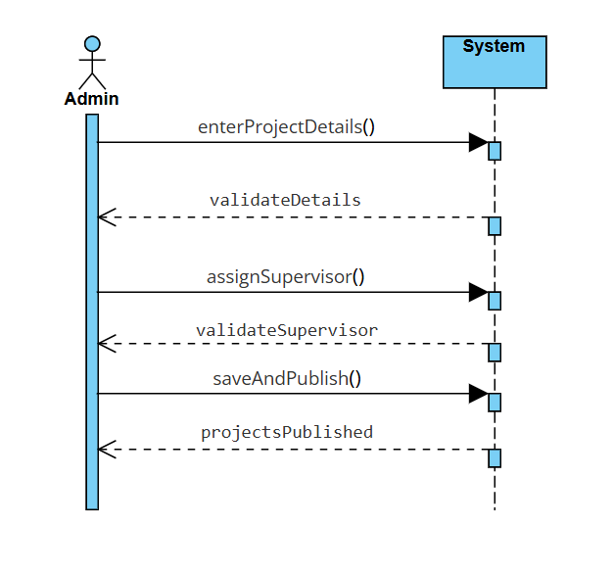

**UC 2: Project Registration**

